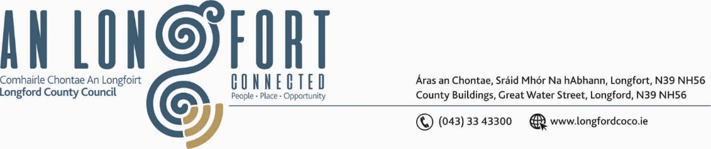

***GRANARD MUNICIPAL DISTRICT***

***Please note meeting will be held in the 98 Hall, Ballinamuck, Longford***

**22 June 2022**

**To: Each Member of Granard Municipal District.**

A Chomhairleoir,

You are requested to attend the Annual Meeting of Granard Municipal District to be held in the **98 Hall, Ballinamuck, County Longford on Tuesday, 28 June 2022 at 3pm** to transact business, as set out on the Agenda hereunder.

Mise le meas,

Ann Marie Mc Keon

_______________

**Ann Marie Mc Keon,**

**Meetings Administrator.**

**C L A R**

**1**. Election of Cathaoirleach.

**2.** Election of Leas Cathaoirleach.

**3**. Fix date and time of Granard Municipal District meetings.

